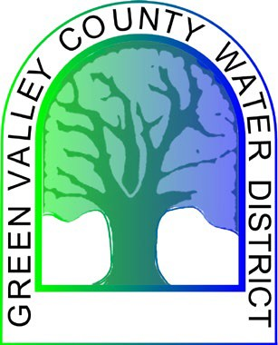
GREEN VALLEY COUNTY WATER DISTRICT
Special Meeting of the Governing Board

AGENDA

February 23, 2023 - 4:00 PM
Held at the
Green Valley County Water District Office, 39520 Calle Cascada, Green Valley, CA
(661) 270-0836

PLEASE TAKE NOTICE that the Board of Directors of the Green Valley County Water District will conduct a Special Meeting to discuss the District Budget (pursuant to California Government Code Section 54956.7)
Next Numbers:
- Introduction Res. XX-23-362
Ord. XX-23-39
- Call to Order by Director at P.M.

- Pledge of Allegiance

- Roll Call: David Phillips, Anthony Castaneda, Joe Randles Bob Garth and Russell Delgado

- Approval of Agenda
Motion by: Seconded by: Vote: YES NO

- PUBLIC COMMENT PERIOD ON AGENDA AND NON-AGENDA ITEMS
  - Any member of the public may address the Board regarding any agenda or non-agenda item that are within the Board's jurisdiction at this point on the agenda.
  - Board member's communication. Board members may announce items of general interest relating to matters within the Board's jurisdiction. There will be no discussion, voting or formal action taken on such items.

- Discussion on District Budget
Motion by: Seconded by: Vote: YES NO

- Meeting Adjourned
Adjournment to next Regular Meeting July 9, 2020 held at the Green Valley County Water District Office, 39520 Calle Cascada, Green Valley, CA Motion by: Seconded by: Vote: YES NO
Adjournment at P.M.
A copy of the agenda is available for examination by the public at the District office of the Board during regular business hours. Please call the office at (661) 270-0836 for general information about the agenda. Questions about specific items on the agenda should be directed to a staff person. Material presented to the Board as part of testimony that is to be made part of the record must be left with the Board. This includes photographs, slides, charts, diagrams, etc. All Board files pertaining to the items on the agenda are hereby made a part of the record submitted to the Board by staff for its consideration prior to action on the related items.

